MINISTRY OF EDUCATION AND SCIENCE OF UKRAINE
National Aviation University (Kyiv, Ukraine)
Batumi Shota Rustaveli State University (Batumi, Georgia)
Batumi Navigation Teaching University (Batumi, Georgia)
Milton Friedman University (Budapest, Hungary)
State Biotechnological University (Harkiv, Ukraine)

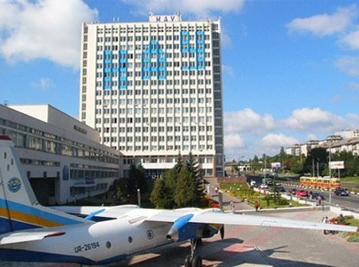

ХІІ^{th} International Scientific and Practical Conference
«MODERN PROBLEMS OF ECONOMY AND BUSINESS»

November 10-11, 2022

assisted by:


UKRAINIAN UNIVERSAL EXCHANGE UKRAINIAN CONTACT CENTER ASSOCIATION ASSOCIATION OF CUSTOMS BROKERS
OF UKRAINE
Department of Economy and Business Technology of the Faculty of Economy and Business Administration of the National Aviation University invites you to participate in the conference:
Seсtion 1. The economy and business: interdependence and development trends.
Section 2. Global trends in digital economy transformation.
Section 3. The customs policy under conditions of deepening of integration processes.
Section 4. Management of business processes for aviation enterprise development.
Section 5. Strategic economic development targets: security, competitiveness, innovation, efficiency.
Section 6. Innovative marketing technologies in the global digital space.
Section 7. Finance, accounting, audit and taxation.

Conference Languages: Ukrainian, English.
Language of the text: Ukrainian, English.
To participate in the conference we invite scientists, scientifically pedagogical workers, representatives of state and business institutions, higher education applicants.
Location: National Aviation University. 1, Liubomyra Huzara ave. Kyiv, Ukraine.
Conditions of participation:
- To take part in the conference you should send to the e-mail KEBT614@ukr.net application and thesis of the report as individual WinWord (.doc) files till November 10, 2022
Contact person: Shtyk Yuliia, Tel. +38 (066) 9836396
- Post-graduates and students should provide materials only with the signature of the scientific supervisor (together with the electronic version of the thesis is sent scanned the first page of the thesis signed by the author and scientific supervisor next to the names).
- Participation in the conference and publication of the electronic collection - for free.
The application form
Last name(s), first name(s), middle name(s)
Name of the institution/ organization
Position(s)
Scientific degree, Academic rank
Educational status | (teacher, student, undergraduate student, postgraduate student, etc.)
Scientific supervisor (for student, undergraduate student, postgraduate student)
Title of the thesis
Session
E-mail
Contact phone number
Consent to personal data processing
The permission to placement materials in open access

REQUIREMENTS REGARDING
The file format - MS Word, A5 paper format, margins – 1,0 cm, font – Time New Roman 10 pt, line spacing – 1, alignment on the width of the screen, paragraph – 1,0 cm, all figures should be monochrome and grouped as a single object, the size of the thesis 3-5 pages. Categorization of thesis should contain the following information:
- the initials and surname of the author (co-authors) (right alignment, bold type);
- the initials and surname of the scientific supervisor, scientific degree, academic rank (right alignment, bold type);
- name of the organization in which the author works or studies (right alignment, bold type);
- title of the thesis (in capital letters, centered, bold type);
- content of the thesis;
- references (according to the latest requirements).
The names of the files containing the conference materials must match the names of the first co-author.
Conference materials will be are located in the institutional repository of NAU. The authors of articles are responsible for the content and reliability of the submitted materials. The submitted materials are published in author's edition.

Conference Thesis Sample
Katamadze David,
Doctor of Economics,
Associate Professor of Batumi Shota Rustaveli
State University, Georgia
PROBLEMS OF BUSINESS RISK MANAGEMENT IN GEORGIA

Тext
References:

